
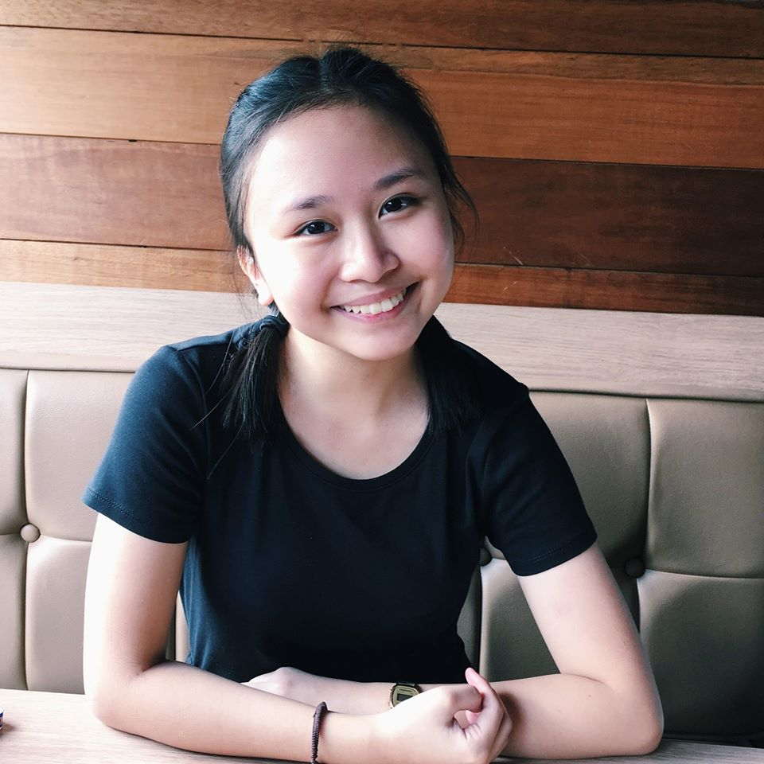
CHRISTIANNE NICOLE GENEVIEVE NIEVES
14 Sunburst Street SSS Village
Concepcion Dos, Marikina 1811
(02)9411-381; +639178636811
christianne_nieves@dlsu.edu.ph

OBJECTIVE
To join an organization where I can use my skills in personnel administration and attain a high level of performance in personnel recruitment and training.

EDUCATION

MIRIAM COLLEGE HIGH SCHOOL
Junior High School Diploma, April 2016. Honorable Mention. Awards: Second Honors A.Y. 2015-2016

MIRIAM COLLEGE HIGH SCHOOL
Senior High School Diploma, April 2018. Honorable Mention Awards: Second Honors A.Y. 2016-2017 and A.Y. 2017-2018

CO-CURRICULAR ACTIVITIES

2017-2018 MAGNIFICAT LAYOUT STAFF
Designed the termly school magazines, online zines and literary folios.

2018 GRADUATION BALL PUBLICITY MEMBER
Layout the souvenir program and designed online publicity materials.

2017 CONCERT COMMITTEE (SILYAB) PUBLICITY HEAD
Headed all publicity and marketing activities of the annual concert. Prepared shirts, online and print materials.

SEMINARS ATTENDED

November 2018 iS med for you?
Andrew Hall, De La Salle University

RESEARCH PAPERS PREPARED

March 2018 A COMPARATIVE STUDY ON THE AMOUNT OF ELECTROLYTES FOUND IN NATURAL JUICES AND ENERGY DRINKS
Discussed the contents, benefits, and measurement of electrolytes in natural juices and energy drinks.

CHRISTIANNE NICOLE GENEVIEVE NIEVES
Page 2

PERSONAL BACKGROUND

Fluent in English and Filipino. Knowledgeable in Adobe Photoshop programs. Interests: eating, sleeping, layouting, and selling.

REFERENCES

ANTILA NIKOLE AFRICA
Best Friend
+639175195795 ani.africa@yahoo.com
Varsity Hills Loyola Heights Quezon City

